[](Http://www.acas.com)

Microsoft Outlook 2010

Refresher Guide

*Prepared By:*

*The IT Training Team*

[*American Capital Strategies, Ltd*](http://acas.com)

*Nasdaq:ACAS*

I. E-mail 4

A. Tips for managing e-mail 4

B. View your Mailbox size 4

C. Clean Up your E-mail Folders 5

D. Addressing Messages 5

E. Working with Folders 6

F. Search Folders 6

G. E-mail archiving – What happens? 7

H. Send a link instead of an attachment 8

I. Save Attachments 8

J. Send a Zipped Attachment 9

K. Flag messages for follow-up 10

L. Manage Junk E-mail 11

M. Set Level of Importance 12

N. Request a Receipt 12

O. E-mail Formats 13

P. Rules, Filters, and Automatic Formatting 13

Q. Work with Views 14

R. Searching e-mail 15

S. Access e-mail with your Internet browser 15

T. Create a Signature 17

U. Out of the Office Assistant 18

V. Desktop Alerts 18

W. Outlook Shortcut Keys 19

II. CALENDAR 20

A. Open a Calendar in a New Window 20

B. View a Team Calendar 20

C. Schedule a Meeting 21

D. Change a Meeting 21

E. Delete a Meeting 21

F. Reply to a Meeting Request 22

G. Add Color labels to Your Meetings 22

H. Edit Calendar Labels 22

I. Add a Second Time Zone 23

J. Print a calendar 24

III. CONTACTS 25

A. Create Contacts 25

B. Create a Contact Group 26

C. Map a Contact 26

Microsoft Office Outlook is central to communication at American Capital. Employees are expected to be proficient with Outlook’s e-mail, calendar, contacts and Public Folder tools.

# E-mail

## Tips for managing e-mail

Managing your e-mail helps you control a busy day. Here’s a major tip: *Don't let your messages pile up.* Try to clear your Inbox by the end of your workday.

### Use folders to organize your mail

### Create Search Folders to help related messages quickly

### Use rules to automatically process messages

## View your Mailbox size

Your 10 GB mailbox tends to fill up quickly. Use these steps to review your mailbox and folder sizes. Minimizing your total mailbox size dramatically improves Outlook’s performance.

### Click the File tab on the Ribbon

### Click Info🡪Cleanup Tools🡪Mailbox Cleanup🡪View Mailbox Size

### The Folder Size dialog box appears and the mailbox and folder sizes are displayed

### Observe which folders are biggest and clean them up by deleting unneeded items

## Clean Up your E-mail Folders

Spend a few minutes once a week cleaning up your e-mail folders. Use these steps to make cleanup fast and efficient:

### Sort the Inbox by each of the following:

* 1. 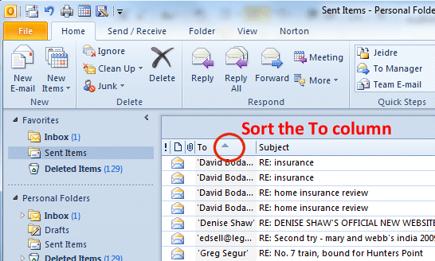**Size**
  2. **From/To**
  3. **Subject**
  4. **Icon**

### Delete e-mail no longer needed

### Do the same for the Sent Items folder

### Do the same for all work folders

### Do the same for Deleted Items folders

## Addressing Messages

The default address book is the ‘Global Address List’; it contains American Capital staff and distribution lists. You can select ‘Contacts’ to address e-mails to personal contacts.

### Get details about a name In the Address Book

#### Click the Home tab on the Ribbon

#### Click the Address Book button

#### Type a last name in the Type name or select from list box

#### Right-click the name

#### Select Properties

#### Click OK when done

## Working with Folders

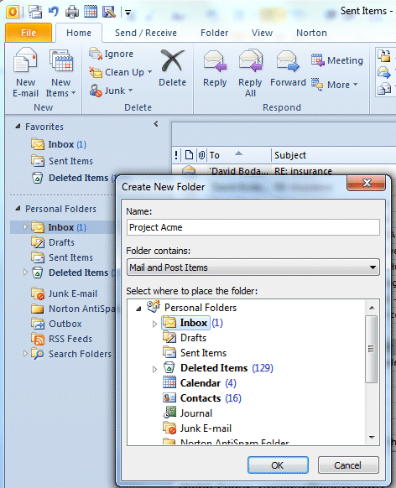Create folders as needed to organize your e-mail Keep projects well organized simplifies corporate e-mail archiving. Make subfolders in your Inbox, project calendars, and contact groups to store your work. Periodically review and clean them out as described later in the ‘Clean up’ section in this manual.

### Create a new Mail Folder in your Inbox

#### Right-click on Inbox

#### Click New Folder

#### Type a folder name

#### Select Inbox

#### Click OK

## Search Folders

Set up Search Folders to quickly find e-mails for your projects. The default Search Folders are: For Follow Up, Large Mail, and Unread Mail. Go through the default Search Folders periodically to weed out unneeded e-mail.

### Click the Home tab

### Right-click on Search Folders

### Click New Search Folder

### Choose a template or create a Custom Search Folder

### Select the options you want

### Click OK

Note: if you open or select one or more e-mail messages shown in a Search Folder and delete them, the messages will be deleted from the Outlook folder where they are stored. When you delete a Search Folder, however, the e-mail messages shown in the Search Folder are not deleted.

## E-mail archiving – What happens?

**E-mail archiving** copies items in your Inbox, Sent items, and sub-folders that are more than 90 days old into an archiving storage computer. To retrieve archived attachments, open the e-mail then double-click the file attachment icon. You may only retrieve archived attachments when your computer is logged into the network, either in an American Capital office or via the VPN.The text of the archived email message is always available.

### Archiving process

All e-mail 90 days and older in your Inbox, Sent Items and folders you have created will be copied to the archive storage computer.   
A ‘shortcut’ icon indicates the message has been archived.



### Accessing archived e-mails

#### In the office

Work with archived e-mails and attachments the same as any e-mail. The archiving process is transparent within the office network.

#### Out of the office

##### Connect to the network with Cisco VPN

##### Work with archived e-mails and attachments as usual. If your Internet connection is slow, large attachments may take a while to open.

### Deleted Items

14 days after you put items into your Deleted Items folder, those items will be automatically and permanently deleted.

### Searching for archived items

Software will be installed on your computer to facilitate searching for archived attachments.

#### Click the View tab on the Ribbon, then click the EmailXtender Search button

#### Type your search criteria and click Find Now

Your search results will be displayed. You can use ‘wildcard’ characters such as an asterisk to broaden your search. Use the More Choices tab to specify additional criteria such as From and To.

## Send a link instead of an attachment

Instead of e-mailing documents to colleagues in your office, send them a link. Sending a link saves time and hard disk space when working with large files.

### Click in the body of the e-mail

### Click Insert🡪Hyperlink

### Select the document to link

### Click OK

**Note:** When receiving a link attachment you will get a warning message about harmful data. Before clicking yes, make sure the e-mail is from a trusted source.

## Save Attachments

If an e-mail contains several attachments, save any or all of them in one step.

### Click the File tab on the Ribbon

### Click the Save Attachments button

### Select the attachment(s) to be saved, Click OK

### Browse and select a folder

### Click Save

## Send a Zipped Attachment

Zipping a file creates a compressed version that is smaller than the original file. Word, Excel and text files compress well; PowerPoint and files that use a lot of images may not get much smaller after zipping.

### Make a new e-mail

### Click the Insert tab

### Click the Attach File button

### Browse and select file(s) to be attached

### Do one of the following:

#### If the .zip file already exists:

##### Double-click the file

#### If the .zip file doesn't exist:

##### Select the file to be attached

##### Right-click on the file

##### From the shortcut menu, click Send to🡪compressed Zip Folder

##### Select the file in a zipped format

##### Click Insert

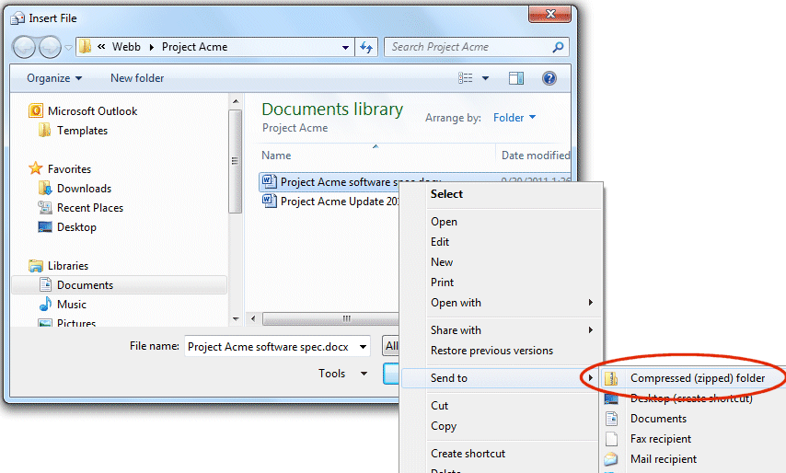

## Flag messages for follow-up

When you can’t respond to e-mail immediately, flag important messages so you can find them quickly. Use the "For Follow Up" folder in Search Folders to view all flagged messages at once. Use colored flags if desired for different kinds of follow-up actions.



### Flag a message

#### Click the Quick Flag icon to add a red flag

#### To have a different flag color, right-click on the flag icon and choose a flag color

### Add a Reminder

#### E-mail must be in the Inbox

#### Right-click the Quick Flag icon

#### Select Add Reminder

#### Select a reminder date and time

#### Click OK

### Remove a Flag

After you’ve dealt with a flagged message, clear the flag or file or delete the message.

#### Right-click a flagged message

#### Select Follow Up🡪Clear Flag

## Manage Junk E-mail

All e-mail sent to you is examined by a corporate spam filter. If the filter thinks the message is suspicious it is placed in quarantine, and you’ll receive an e-mail notifying you that you have quarantined items. Click the link in the e-mail to go to your quarantine bin and release, whitelist or delete quarantined items. [See the IronMail Quick Start document in All Public Folders🡪G. 🡪IT Info for Employees🡪 Software]

If e-mail evades the spam filter you can add it to a Blocked Senders list:

### Right-click the spam message in your Inbox

### Rest your cursor on Junk

### Select Block Sender

Periodically examine and empty your Junk E-mail Folder too.

### Right-click the Junk E-mail folder

### Select Empty Folder

### Tips to reduce Junk e-mail

#### Turn off automatic processing of meeting requests and read and delivery receipts. Spammers sometimes resort to sending meeting requests and messages that include requests for read and delivery receipts.

#### Limit where you post your e-mail address. Be cautious about posting your e-mail address on public Web sites, and remove your e-mail address from your personal Web site. If you list or link to your e-mail address, you can expect to be spammed.

#### When browsing the Internet, watch out for check boxes that are already selected. When you shop online, companies sometimes add a check box (already selected) saying you agree to let them sell or give your e-mail address to other businesses. Clear the check box so that your e-mail address will not be shared.

#### Don't reply to spam. Never reply— not even to unsubscribe— unless you know and trust the sender. Answering spam just makes you a target for more junk mail.

#### Don't forward chain e-mail messages. Besides causing more traffic, by forwarding a chain e-mail message you might be furthering a hoax— and meanwhile, you lose control over who sees your e-mail address.

## Set Level of Importance

Mark important messages with an exclamation mark to alert recipients the message needs attention. Setting the level of importance also enables the e-mail recipients to sort messages by importance.

### Create a new e-mail

### Click the High Importance red exclamation mark on the Message tab in the Ribbon

## Request a Receipt

You can track messages you send by requesting a receipt.

### Make a new e-mail

### Click the Options tab on the Ribbon

### Check the box the for the desired receipt

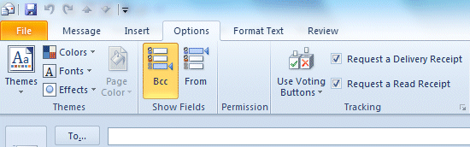

## E-mail Formats

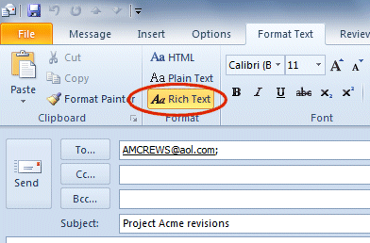Microsoft Outlook gives you the option to send and receive e-mail in Rich Text, HTML and Plain Text formats. American Capital uses only Rich Text – it supports the richer formatting features of Word, Excel and PowerPoint. If you receive an e-mail in HTML or Plain Text, you may want to change the format to Rich Text before forwarding to American Capital staff.

### Change e-mail format

#### Open the e-mail which doesn’t have Rich Text formatting

#### Click the Format Text tab

#### Click Rich Text

#### Compose and send the e-mail

## Rules, Filters, and Automatic Formatting

You can create rules to automatically manage e-mail. When a message arrives in your Inbox, rules can automate many tasks (such as move, delete, copy, reply to, and print a message) and can perform other tasks such as play a sound, start a program, and run a script.

### Click the Home tab on the Ribbon

### Click Rules🡪Create Rule

### Select a template

### Edit the rule description

### Click Next

### Select conditions

### Select a folder

### Click Next

### Name the Rule

### Choose Setup rule options

### Click Finish

## Work with Views

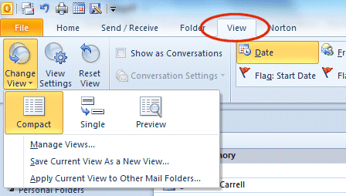There are three predefined views. You can change a view to use a predefined group or sort.

### Change a View

#### Click the View tab on the Ribbon

#### Click the Change View button

#### Select an arrangement you want

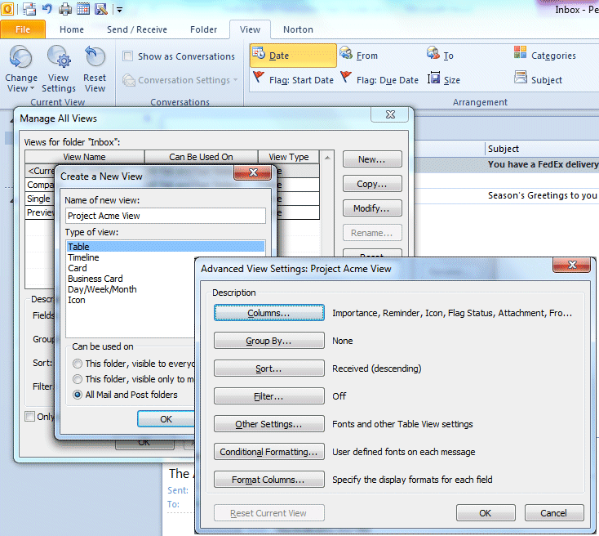

### Create a Custom View

#### Click Change Views🡪Manage Views🡪New

#### Select the options you want

#### Click OK

### Group or ungroup items in a View

You can automatically apply grouping as part of a standard arrangement, or you can manually group items to create your own grouping.

#### Right-click on the From, To, or Subject column header

#### Select Arrange By🡪Show in Groups

## Searching e-mail

You can search for a message or item in your Outlook by a click of a button.

### Click the Search tab on the Ribbon

### Click a search criterion button, then type search text in the search box

### You may select more than one search criterion to narrow the search

## Access e-mail with your Internet browser

You can check e-mail inside and outside the office using Outlook Web Access (“OWA”). When outside the office, there are two ways to access mail. The first is using your VPN (NetExtender or Sonic Wall VPN) plus the Outlook application. The second way is using your RSA Secured token allows you to access American Capital e-mail via any computer with an internet connection.

### Check e-mail inside the office

#### Open your internet browser

#### Type mail_acas in the address window and hit Enter

#### OWA will open

### How to check your corporate e-mail from any computer

You can use your RSA SecurID token to log into e-mail from a home or public computer that is connected to the Internet. The token must be activated before you use it. (See the RSA SecureID quick in All Public Folders | G. | Info for Employees | Software).

#### Go to <https://mail.americancapital.com>

#### Click the Yes button

#### Type your network login in the User Name box (FirstName.LastName)

#### Type your PIN followed by the SecurID code in the Password box *Example: PIN is 4444, RSA SecurID key code is 320658 Type 4444320658 in the Password box*

#### Click Send

#### The ACAS Remote Mail screen opens

#### Type your login as FirstName.LastName@esops.com

#### Type your network password

#### Click OK

#### OWA will open

#### Click the Log Off button in Main Menu when you have finished your OWA session

#### Click Close on the OWA Web Access dialogue box

## Create a Signature

You can create custom signatures that are automatically added to the end of an outgoing e-mail message. An e-mail signature consists of text and/or pictures. You can add just your first name for messages to friends and family, and use a separate signature with your full name and e-mail address for business e-mail. Make sure your default business signature has the American Capital disclaimer added to it.

### Click the File tab🡪Options🡪Mail🡪Signatures

### Click New

### Type a name for the new signature’ box

### Click OK

### In the Signature text box, insert or paste a signature

### Select the text

### Adjust font and paragraph settings as desired

### Click OK

### When composing e-mail, click the Signatures button to select an alternate signature if desired

**Note:** When sending business e-mails be sure the disclaimer appears.   
Sample disclaimer text:

*Disclaimer:*  The information contained in this e-mail message is intended for use by the recipient(s) named above. If the reader of this message is not the intended recipient, you are hereby notified that you have received this document in error and that any review, dissemination, distribution, or copying of this message is strictly prohibited. If you have received this communication in error, please notify me immediately by e-mail and delete the original message.

## Out of the Office Assistant

Use the Out of Office Assistant to automatically send a reply to e-mails. The Assistant will reply *once* to each sender.

### Click the File tab.

### Click Automatic Replies.

### Select Send automatic replies.

### If desired, click the ‘Only send during this time range’ check box. If you don’t specify a start and end time, auto-replies are sent until you select the ‘Do not send automatic replies’ check box.

### On the Inside My Organization tab, type the response that you want to send to teammates or colleagues while you are out of the office.

### On the Outside My Organization tab, select the Auto-reply to people outside my organization check box, and then type the response that you want to send while you are out of the office. Select whether you want replies sent to My contacts only or to Anyone outside my organization who sends you messages.

## Desktop Alerts

A Desktop Alert notification appears when you receive an e-mail, note, meeting request or task request. Use Desktop Alerts to "pre-process" incoming items without having to open your Inbox first. You can flag a message, delete it, or mark it as read — all without switching to your Inbox.

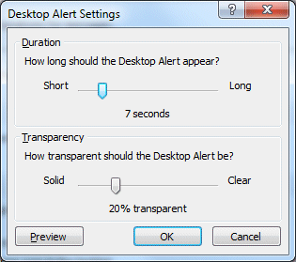

### Modify Desktop Alert settings

#### Click the File tab

#### Click Options🡪Mail🡪Desktop alert Settings

#### Modify the desktop alert settings as desired

Note: If several items arrive in your **Inbox** at the same time, you won't necessarily receive a Desktop Alert for each item. Microsoft Outlook displays a single Desktop Alert to indicate that you received several new items.

## Outlook Shortcut Keys

Using keyboard shortcuts is a great way to save time. These shortcuts are very handy:

**Ctrl n**  Create a new e-mail

**Alt r** Reply

**Alt l (“el”)** Reply to all

**Ctrl Shift b**  Display the address book

**Ctrl Shift a** Open a new appointment

**Ctrl Shift q** Open a meeting request

**Ctrl d**  Delete an e-mail message, contact, calendar item, or task

**Ctrl m**  Check for new mail

# CALENDAR

In addition to your personal calendar, team calendars are available for each American Capital office and departments in Bethesda. Team calendars improve communication among team members and should be used routinely to help you determine when your colleagues are free or busy. Events added a team calendar are automatically copied to the Corporate calendar.

## Open a Calendar in a New Window

When you start launch Outlook it’s useful to immediately open your personal calendar and your team calendars in separate windows. Doing so makes scheduling meetings faster and easier.

### Right-click the calendar you want to open in a new window

### Click Open in New Window

## View a Team Calendar

### From the folder list, click Public Folders🡪All Public Folders🡪Tools🡪Calendars

### Click the calendar you wish to view

## Schedule a Meeting

### Double click the meeting date in a calendar

### Click the To button and select invitees

### Add information in the subject line: brief description of the event.

### Type location information: conference room name or client location or telecom dial-in number and access code

### Select meeting duration

### Add a reminder

### Select a Category

### Fill in the detail area with notes, an agenda, file attachments, etc.

### Click the Send button to send meeting invitations

## Change a Meeting

### Open the meeting in your personal calendar

### Adjust to the date and time as desired

### Click Send Update

### Click Save and Close

## Delete a Meeting

### Open the meeting in your personal calendar

### From Main Menu click Delete

### In the alert dialog box select the proper notice

### Click OK

### Click Send

## Reply to a Meeting Request

### Open a meeting request

### On the Message tab, in the Respond group, click Button imageAccept, Button imageTentative, or Button imageDecline.

### Select a response from the dialog box

### Click OK

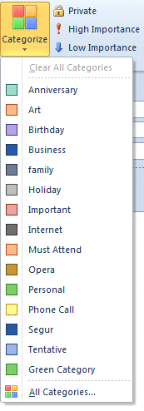**Note:** Whenever you propose a new time, it is sent with a default message that says you want to propose a new time, but that you have tentatively accepted the meeting.

## Add Color labels to Your Meetings

Outlook has 15 colors that you can use to visually organize appointments and meetings. You can color individual or recurring appointments and meetings manually, or use rules to automatically color items that meet conditions you specify. When you open another person’s calendar or a team calendar, only color labels that were assigned manually are visible. Automatic coloring can be seen only by the person who created the meeting.

### Create a new meeting or appointment

### Click the Category button and select a color

### Complete and send or save the meeting or appointment

## Edit Calendar Labels

Each color comes with a pre-assigned label. You can change them if you wish.

### Click the Categories button

### Click All Categories

### Add, delete, rename, recolor categories as desired

## Add a Second Time Zone

If you work on projects in different regions, add another time zone label to your calendar. The second time zone is shown as a bar in Calendar view, and makes it easy to schedule meetings with people in our Europe or Hong Kong offices.

### Click the File tab on the Ribbon

### Click Options🡪Calendar

### Click Time Zone

### Click the Show a second time zone check box

### Type a name for the second time zone in the Label box

### Select the time zone you want to add from the Time zone menu

### To remove the extra time zone just clear the Show a second time zone check box

**Note:** You can switch your current time zone to the second time zone by clicking Swap Time Zones. This affects all times displayed in Outlook as well as times displayed in other Microsoft Windows-based applications.

## Print a calendar

### Select your calendar

### Click the File tab on the Ribbon

### Click Print in the left menu

### Select a print style from the display box

### Click the Print Options button to select start and end date ranges

### Click the Print button

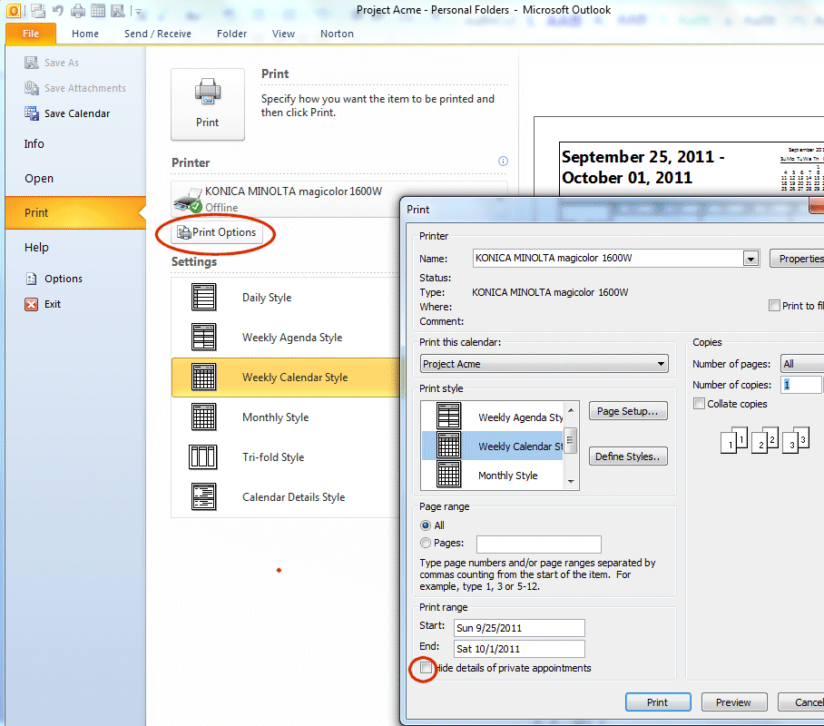

Notes: To print the details of private appointments, clear the Hide details of private appointments check box.

# CONTACTS

Your Contacts folder is a personal contact database. Use it to store contacts unrelated to the company’s master Saleslogix contacts database. You can create your own contact entries or import existing contacts from Saleslogix.

## Create Contacts

### Click New Items🡪Contact

### Add contact data. Use the Full Name, Phone Number and Address menus to keep information consistent.

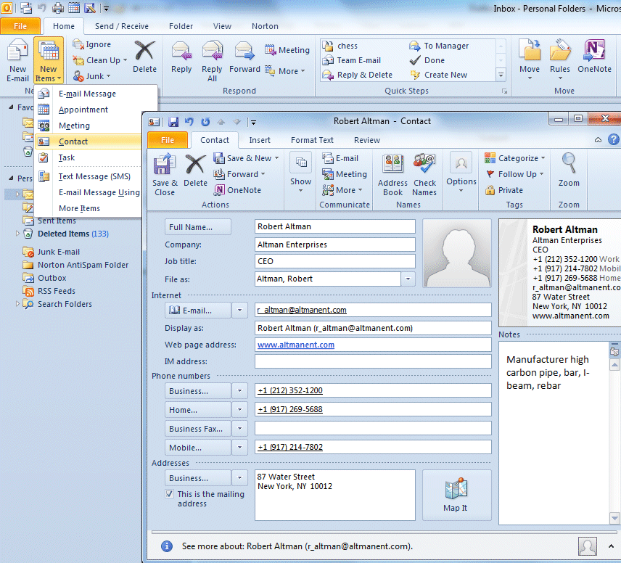

## Create a Contact Group

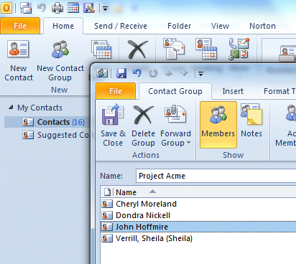Create Contact Groups for your projects. It saves time and improves project management.

### From the main menu, click Tools | Address Book

### From the Address Book Menu, click File | New Entry

### From the New Entry dialog box, select New Distribution List

### Type the name of your list in the List Name text box

### Select members from the Select Members Dialog box

### Click Add

### Click Save and Close

### Send only to selected members of Contact Group

#### Enter the Distribution name in the *To* box

#### Click the expand button to the left of the list name to expand the list

#### Click OK

#### Edit the names from the list

#### Click Send

## Map a Contact

### Open a contact

### Clip the Map It button

### **Bing** displays a map of the contact’s address in a browser window