CISCO ANYCONNECT VPN Quick Start

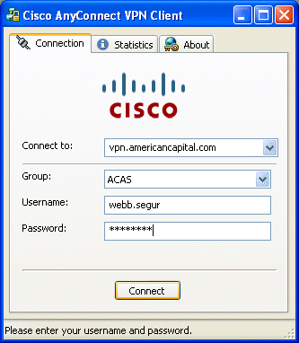
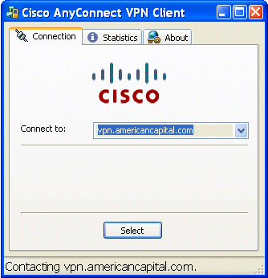
Cisco Virtual Private Network (VPN) is the new way to connect your American Capital laptop to the network when you are out of the office. It is very easy to use!

Launch Cisco VPN
Click StartAll ProgramsCiscoCisco AnyConnect VPN Client Cisco AnyConnect VPN Client

If prompted, click ‘Select’
The Select button may only appear briefly, and change automatically to the Connect button below.

Enter your password, click ‘Connect’
1. The connection dialog box is displayed.
2. Type the password you use when you start
your computer.
3. Click the Connect button.
The connection dialog box disappears.

a connection icon is displayed
An icon appears in the notification area in the system tray. The lock icon indicates you are connected
to the network.

No lock means connection was dropped.
Double-click the icon to reconnect.
If you observe the Cisco icon has no lock,
it means you have lost connection to the
network.
Just double-click the icon and reconnect.

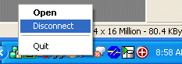
Disconnect when done
Right-click the VPN icon, then left-click Disconnect.
Right-click the icon in the notification area
and choose Disconnect.

Create a desktop shortcut
Adding a Cisco VPN shortcut to your Desktop will save you time connecting to the VPN.
1. Click Start.
2. Walk your mouse to All ProgramsCisco Cisco AnyConnect VPN Client
Cisco AnyConnect VPN Client.
3. Right-click Cisco AnyConnect VPN Client and choose Send toDesktop (create shortcut).
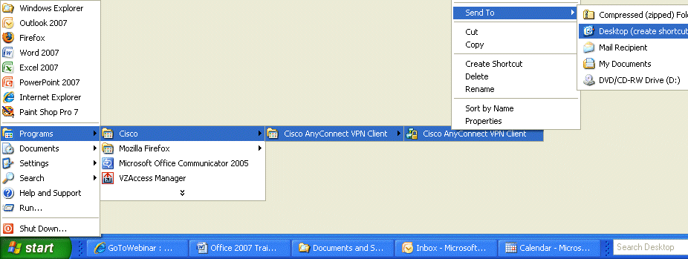
Right-click Cisco AnyConnect VPN Client and choose Send toDesktop (create shortcut)
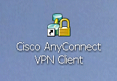

4. The shortcut is created.

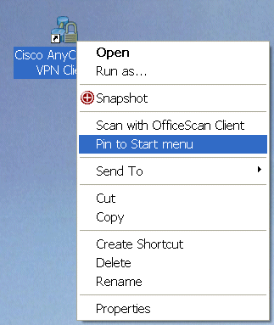

If you like to keep a tidy desktop, add the shortcut to your Start menu instead:
1. Right-click the shortcut.
2. Select ‘Pin to Start menu’.
The shortcut is added to your Start menu.
3. Delete the shortcut from your desktop.

